



Name of Assignment : Set Exercise (Practical)
Programme Title : Predictive Analytics and Machine Learning using Python
Name: JIMSON JAMES T
Year:2025-2027

Table of Contents
1. Introduction
2. Task 1 – Decision Tree Analysis
2.1 Problem Description
2.2 Entropy of the Parent Dataset
2.3 Information Gain for Attribute “Type”
2.4 Attribute Selection Discussion
3. Task 2 – K-Means Clustering
3.1 Objective
3.2 Dataset and Preprocessing
3.3 K-Means Implementation
3.4 Results and Interpretation
4. Task 3 – Regression Analysis
4.1 Objective
4.2 Model Selection
4.3 Model Training and Evaluation
4.4 Trend Analysis
5. Conclusion
6. References
7. Appendix

Statement of compliance with academic ethics and the avoidance of plagiarism

I honestly declare that this dissertation is entirely my own work and none of its part has been copied from printed or electronic sources, translated from foreign sources and reproduced from essays of other researchers or students. Wherever I have been based on ideas or other people texts I clearly declare it through the good use of references following academic ethics.
(In the case that is proved that part of the essay does not constitute an original work, but a copy of an already published essay or from another source, the student will be expelled permanently from the program).

Name and Surname :
JIMSON JAMES T
.......................................................................................................................................

Date: .......03................../...02......./.....2026....

1 INTRODUCTION
Machine learning and predictive analytics has since become an important part and aspect of the modern data-driven decision making since organisations are now able to convert raw data into insight and information which could be used to deploy tactical and operational decision making. The methods help organisations to not only draw out trends based on historical data but also use the same to help organisations be able to make forecasts, make categorization and segmentation. The provided assignment assists to demonstrate how the main ideas of machine learning could be implemented with the help of Python related to learning tasks based on classification, clustering, and regression models.
The module learning outcomes correspond to the extent of this report, such as the efficient organization of the various data types and preprocessing techniques, forecasting real-world information with the help of predictive models, and the overall use of the machine learning algorithms with the help of Python. The three processes included entropy, information gain to create decision tree, K-Means clusters to locate the portions of the data and regression which determine the distribution of the patterns of returns within the stocks.2 Task 1 – Decision Tree Analysis
2 Task 1 - Decision Tree Analysis
2.1 Problem Description
The first one will be the analysis of a small categorical array of data at the end of which will be the reflection on purchases of a wine product in the past. Four attributes that are used to define every wine are its price, type, characteristic and origin. The dependent variable is the positive or negative purchase of the wine which is a binary class variable.

2.2 Entropy of the Parent Dataset
Entropy at this point is a quantitative concept of the uncertainty within a set of data and is generally used in the decision tree learning algorithm to find the best (optimal) divisions of data.
$$Entropy(S)=-∑p_{i}{log⁡}_{2}(p_{i})$$
The findings of the given data set showed that 4/10 of the wine was to purchase and 6/10 to not purchase. The entropy of the parent dataset prior to any splitting amounts to approximately 0.97, and it implies that some amount of uncertainty is relatively high.
2.3 Gain of Information of attribute type.
Information gain is used to measure the decrease in entropy following split of the data on the basis of a given attribute. While partitioning the data using the attribute Type, one can also considerably decrease the weighted entropy of the obtained subsets. The information gain that was calculated under Type is 0.57, which is relatively good.
2.4 The Discussion of the Attribute Selection.
The attribute Type suggests the greatest decrease in entropy; therefore, it will be used as a root node of the decision tree. Following this schism, some branches are still impure. In the case of these branches, several attributes can have comparable values of information gain. Thus, the next attribute selection is not a unique one and various decision trees with the same performance could be created.
3 Task 2 - K-Means Clustering
3.1 Objective
The objective of task 2 alone is to apply K-Means clustering algorithm in order to group a numerical data into logical clusters. Clustering- The clustering is a supervised learning technique that is employed in order to reveal the natural forms of unmarked information.
3.2 Dataset and Preprocessing
The information was represented in the form of Numica array within a text file. It was carried out in form of a raw text file which was transformed into numerical NumPy array in a safe manner. The data was first subjected to StandardScaler which enables the clustering of the data since all the features would equally contribute to the distance estimate.
3.3 K-Means Implementation
K-Means cluster was applied and the clusters had three clusters. The decision is open to interpretation and simplicity. The algorithm helps in classifying the data points into the nearest centroid till the convergence is achieved with reconstruction of cluster centres.
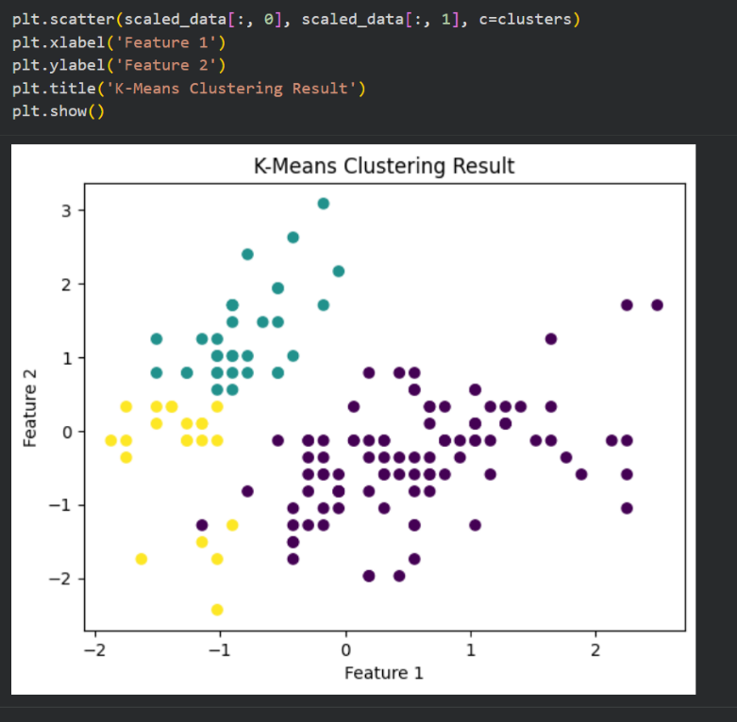
Fig 1
3.4 Results and Interpretation
Fig 1 addresses the achievement of K-Means in the implementation of the K-Means in Google Colab whereby the separation of observation is conducted in special three groups following the establishment of the standardisation of the features.
Three clusters were obtained due to the clustering. It will also cluster the observations that contain the same measure of features and, therefore, would allow the natural grouping of set of data that will be represented. These kinds of segmentation may be applied in such services as behavioural or profiling of a customer.
4 Task 3 - Regression Analysis
4.1 Objective
The third assignment is the analysis of the returns of a portfolio as a dependant variable in the scale of risk. It will be the goal to estimate the good regression model, to examine its quality and to define the trends of the data.
4.2 Model Selection
Scatter plot Sight view of scatter plot indicates that relationship between the risk and the returns is non-linear. As a result, it was necessary to take the second degree regression
model of a polygametic character, which is able to accommodate Curvature on the data, and can be analysed.

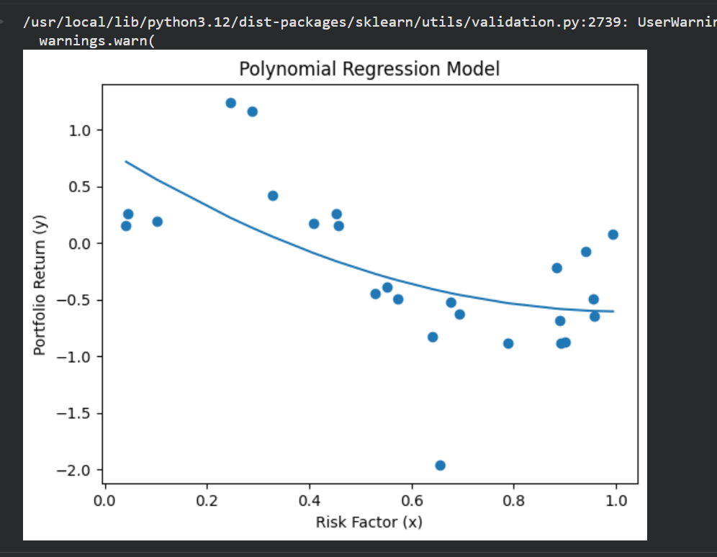
Figure 2

4.3 Training model and a Testing it.
The regression model was built and tested using the help of python the Google Colab. The best fit poly linear regression curve has been superimposed either on the data points it fits as shown in figure 2.

The regression model was trained using the help of degree two poly of field. Model performance was measured by using two of these measures where one was coefficient of determination or R2 and other, Mean Squared Error or MSE. The model was found to have resulted in a score of 0.37 in R 2 and had a score of 0.28 of MSE.

4.4 Trend Analysis

In the fitted regression curve, there is a negative non-linear relationship between the risk and returns. During low risk, there is no major fluctuation of returns whereas in case of high risk there is a falling tendency of returns. The financial theory is consistent with this kind of behaviour since diminishing returns is experienced when exposures to risk increase.

5 Conclusion

Overall, it is possible to state that the approaches to predictive analytics are implemented prudently and where the proper choice of model, strict evaluation and analysis of outcomes are a maintained.

This assignment did teach the way of use of a variety of machine learning in Python. The entropic analysis, the utilization of information gain revealed in the classification of the tasks depending on the decision tree analysis. Numerical data could be clustered using K-Means algorithm and the poly-regression has been in position to create non-linear relationship among returns and portfolio Risk.

In general, the findings demonstrate how the predictive analytics solution can be utilized in addressing the problems in the real world beginning with the decision making process, followed by the identification of patterns, and trend analysis. The application addresses the learning module outcomes while also the application demonstrates how machine learning algorithms can be applied in the context of data analytics.

6. References
Hastie, T., Tibshirani, R. and Friedman, J. (2009). *The Elements of Statistical Learning*. New York: Springer.
James, G., Witten, D., Hastie, T. and Tibshirani, R. (2021). *An Introduction to Statistical Learning*. New York: Springer.
Pedregosa, F. et al. (2011). ‘Scikit-learn: Machine Learning in Python’, *Journal of Machine Learning Research*, 12, pp. 2825–2830.

7. Appendix
https://colab.research.google.com/drive/1Rms6N-Lkno-KqFmKtQfHMHLkit74jLfT?usp=sharing
https://github.com/jimsonjames007-debug/msc-predictive-analytics-machine-learning.git

